###### Food Order System

Program Installation guide

Tony Mai

Ryan Chen

1. Download and install the Visual Studio Community

<https://www.visualstudio.com/downloads/>

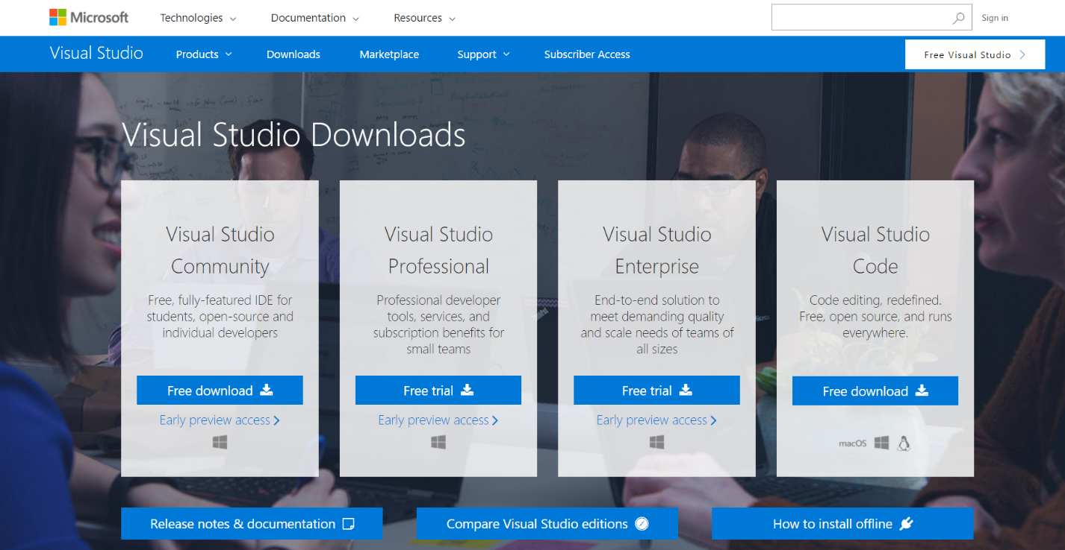

1. After select Universal Window Platform Development, and click install.

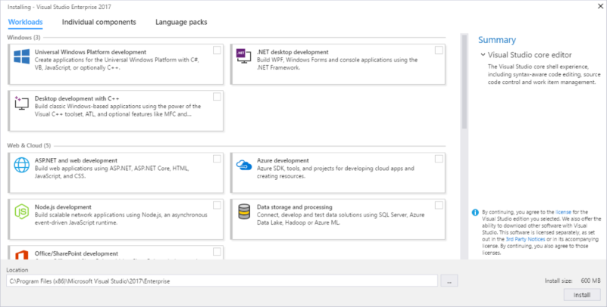

1. Unzip the CSC424_Final

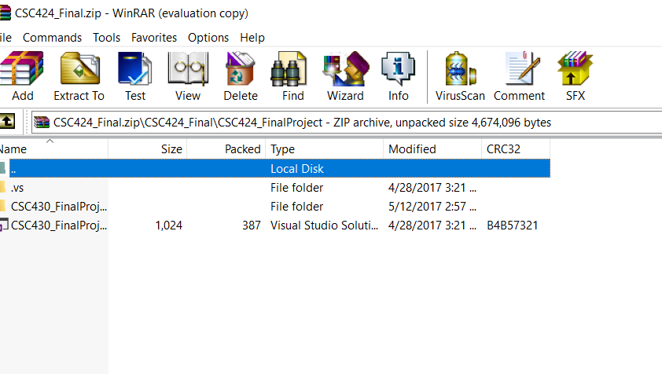

1. Run the CSC430_FinalProject.sln
2. In the Solution Explorer, double click the Edit_Information.cs under Folder Form.

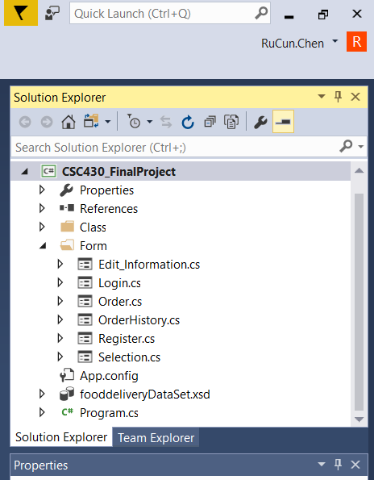

1. After opening window form, double click it to open code of the form.

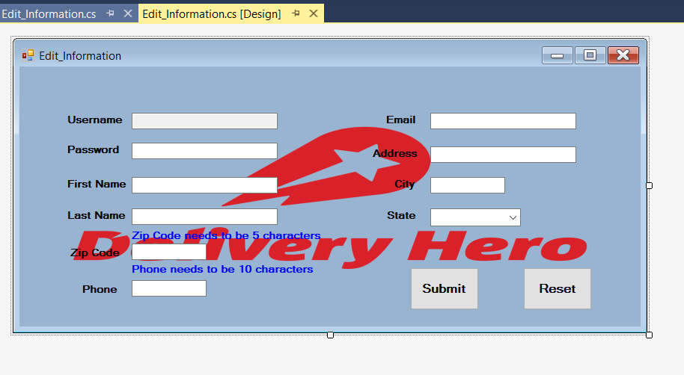

1. Change the connection of the database you want to work on.

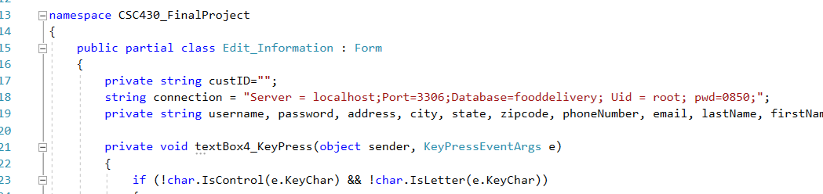

1. Repeat the Process 5,6,7 with other forms Login.cs, Register.cs, Order.cs and OrderHistory.cs.
2. Final, Ctrt+F5 to start running the program.